[TAB] Table of Contents
Each section has a tag you can search for using CTRL + F

Chopsticks Overview [OS]
Summary of Commands [SUM]
Command Details [COM]
Error Messages [ERR]
Index [IND]

[OS] Overview of the Chopsticks Operating System

Chopsticks is an interactive console based operating system
that allows users to input commands to manipulate data and
to control the operating system.

[SUM] Summary of Commands

Chopsticks performs actions based on the keywords you type
in to issue commands. Chopsticks will eventually allow users
rename the keywords in order to map them to easier naming
conventions, however, these are the commands made available
currently:

GET DATE - Gets the current date.

SET DATE - Sets the current date.

LIST - Lists all files in the current directory.

VERSION - Displays current OS flavor and version number.

HELP - Lists available commands.

EXIT - Exits the Chopsticks OS.

SUSPEND PCB - Suspend a Process Control Block

RESUME PCB - Resumes a Process Control Block

SET PRIORITY - Sets the priority of a Process Control Block

SHOW PCB - Shows a Process Control Block

SHOW ALL - Shows all PCBs

SHOW READY - Shows all ready PCBs

SHOW BLOCKED - Shows all blocked PCBs

Full Knowledge Schedulers

SJF – full knowledge shortest job first scheduler

Incomplete Schedulers

FIFO – incomplete first in first out

STCF – incomplete shortest time to completion

FPPS – fixed priority pre-emptive scheduling

RR – Round Robin Scheduling

MLFQ – Multilevel Feedback Queue

LS – Lottery Scheduler

[COM] Command Details

GET DATE

Gets the current date.

SET DATE

Sets the current date.

Invalid date:

LIST

Lists all files in the current directory.
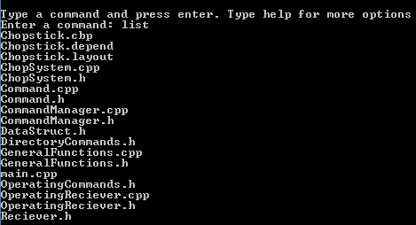

VERSION

Displays current OS flavor and version number.
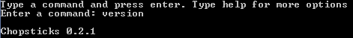

HELP

Lists available keywords and keyword descriptions.
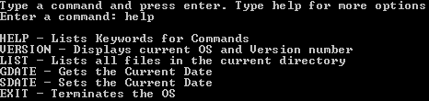

EXIT

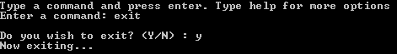
Exits the Chopsticks OS.

SUSPEND PCB

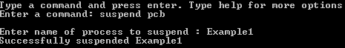
Suspend a Process Control Block

RESUME PCB

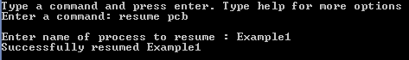
Resumes a Process Control Block

SET PRIORITY

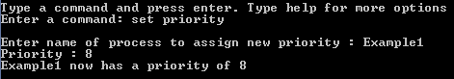
Sets the priority of a Process Control Block

SHOW PCB

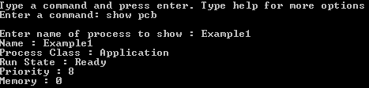
Shows a Process Control Block

SHOW ALL

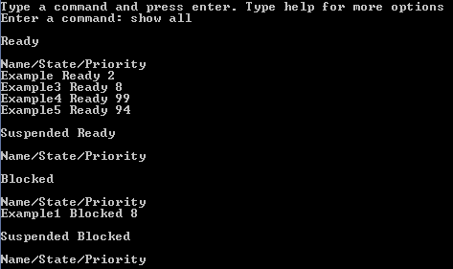
Shows all PCBs

SHOW READY

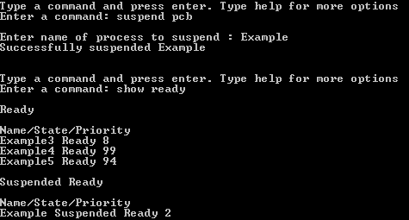
Shows all ready PCBs

SHOW BLOCKED

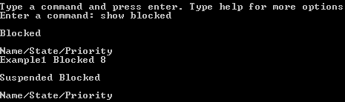
Shows all blocked PCBs

[ERR] Summary of Error Messages

"Invalid command. Please use the help command for more options."
Error occurs when you enter an incorrect command.

"Not a valid date. Date unchanged. "
Error occurs when invalid date values are used to change date.

"Unable to locate current file directory."
Error occurs when the current directory fails to load.

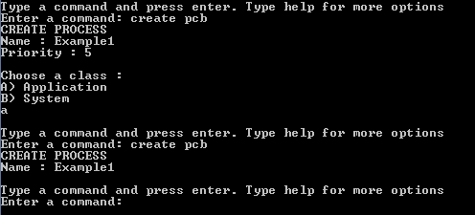
CREATE PCB will not create duplicates if they exist.

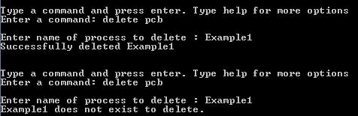
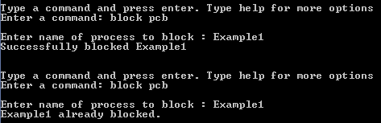
DELETE PCB will not delete items that do not exist.

BLOCK PCB will not block PCBs that are currently blocked.

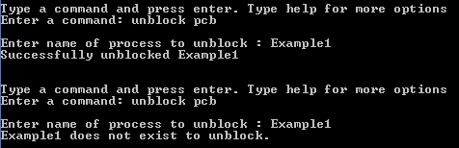
Cannot unblock a PCB that isn't blocked or doesn't exist.
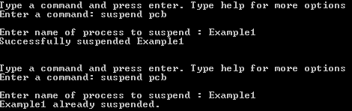
Cannot suspend a suspended PCB.

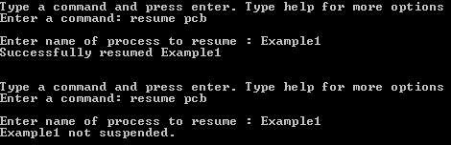
Cannot resume a PCB that isn't suspended.

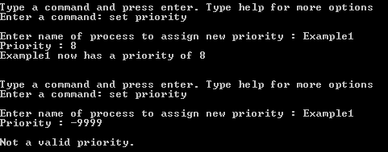
Cannot set non-valid priorities.

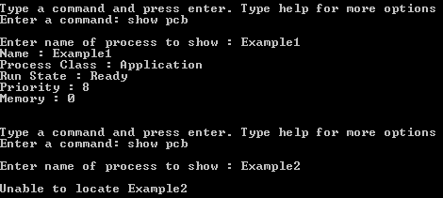
Cannot show PCBs that do not exist.

[IND] Index

